TR4 ENGINE SERVICE NOTE

INSTALLING DISTRIBUTOR AND PEDESTAL TO GET CORRECT TIMING

This is based on the Triumph Workshop Manual, Pg. 1131 and Fig. 68, Fig. 69 and Fig. 70.

See Fig. 68 at end of document for cut-away drawing of assembly.

Position the crankshaft at T.D.C. with No. 1 piston on the compression stroke.

Fit the woodruff key to the oil pump drive shaft and lower the shaft into the bush, engaging the driving tongue with the oil pump driving slot. Rotate the drive shaft such that the woodruff key is pointing away from the engine block and towards the left front fender. Looking down onto the drive shaft while standing at the left front fender, the woodruff key should be at the 6:00 position. To put it another way, the woodruff key should be at 90° to the axis of the crankshaft, pointing to the left front fender.

Now lower just the distributor drive gear (without the pedestal) down onto the drive shaft. As the distributor gear engages the woodruff key both the gear and drive shaft will start to turn clockwise (when looking down on it) as the gear engages the camshaft gear.

With the drive gear all the way down (and resting on the drive shaft bushing) the distributor drive slots must be pointing at the #1 exhaust push rod tube (the push rod tube farthest forward). The woodfuff key is halfway between 6:00 and 9:00 (7:30) and the distributor drive slots are pointing from 4:30 to 10:30. It should look as in the photo below.

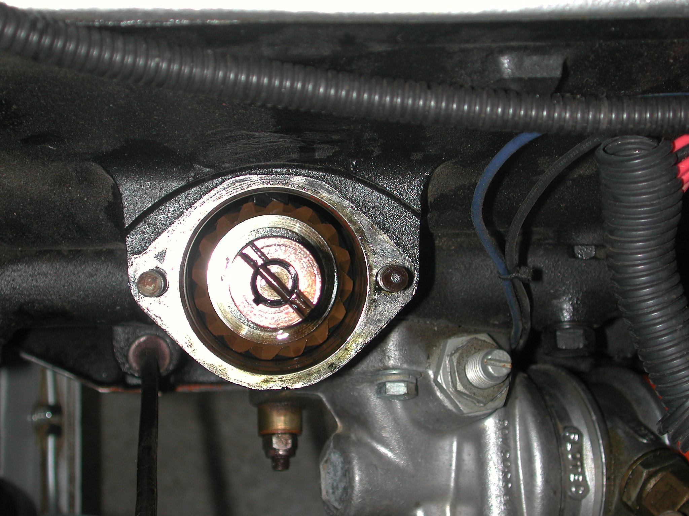
The distributor pedestal and distributor are now installed, turning the distributor shaft to engage the distributor drive slots in the drive gear. The distributor rotor must be pointing at the #1 exhaust push rod tube (the push rod tube farthest forward). It should look as in the photo below.



